Java Dates

Java does not have a built-in Date class, but we can import the java.time package to work with the date and time API. The package includes many date and time classes. For example:

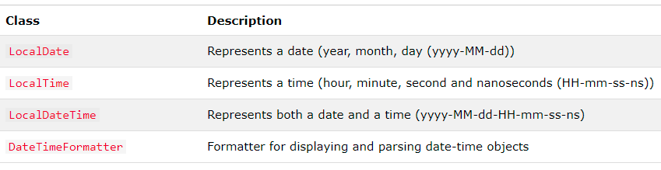

## Display Current Date

To display the current date, import the java.time.LocalDate class, and use its now() method:

import java.time.LocalDate; // import the LocalDate class

public class Main {

public static void main(String[] args) {

LocalDate myObj = LocalDate.now(); // Create a date object

System.out.println(myObj); // Display the current date

}

}

## Display Current Time

To display the current time (hour, minute, second, and nanoseconds), import the java.time.LocalTime class, and use its now() method:

### Example

import java.time.LocalTime; // import the LocalTime class

public class Main {

public static void main(String[] args) {

LocalTime myObj = LocalTime.now();

System.out.println(myObj);

}

}

## Display Current Date and Time

To display the current date and time, import the java.time.LocalDateTime class, and use its now() method:

### Example

import java.time.LocalDateTime; // import the LocalDateTime class

public class Main {

public static void main(String[] args) {

LocalDateTime myObj = LocalDateTime.now();

System.out.println(myObj);

}

}

## Output: 2021-03-31T09:16:23.483

## Formatting Date and Time

The "T" in the example above is used to separate the date from the time. You can use the DateTimeFormatter class with the ofPattern() method in the same package to format or parse date-time objects. The following example will remove both the "T" and nanoseconds from the date-time:

### Example

import java.time.LocalDateTime; // Import the LocalDateTime class

import java.time.format.DateTimeFormatter; // Import the DateTimeFormatter class

public class Main {

public static void main(String[] args) {

LocalDateTime myDateObj = LocalDateTime.now();

System.out.println("Before formatting: " + myDateObj);

DateTimeFormatter myFormatObj = DateTimeFormatter.ofPattern("dd-MM-yyyy HH:mm:ss");

String formattedDate = myDateObj.format(myFormatObj);

System.out.println("After formatting: " + formattedDate);

}

}

Output:

Before formatting: 2021-03-31T09:10:23.463

After formatting: 31-03-2021 09:10:23

SimpleDateFormat Date and time formats are specified by date and time pattern strings.

Within format strings, unquoted letters from 'A' to 'Z' and from 'a' to 'z' are treated as format letters representing the components of a date or time string.

## Pattern

The following pattern letters are defined:

|  |  |  |
| --- | --- | --- |
| **Letter** | **Date or Time Component** | **Examples** |
| G | Era designator | AD |
| y | Year | 2014; 14 |
| Y | Week year | 2014; 14 |
| M | Month in year (context sensitive) | July; Jul; 07 |
| L | Month in year (standalone form) | July; Jul; 07 |
| w | Week in year | 27 |
| W | Week in month | 2 |
| D | Day in year | 189 |
| d | Day in month | 10 |
| F | Day of week in month | 2 |
| E | Day name in week | Tuesday; Tue |
| u | Day number of week (1 = Monday, ..., 7 = Sunday) | 1 |
| a | Am/pm marker | PM |
| H | Hour in day (0-23) | 0 |
| k | Hour in day (1-24) | 24 |
| K | Hour in am/pm (0-11) | 0 |
| h | Hour in am/pm (1-12) | 12 |
| m | Minute in hour | 30 |
| s | Second in minute | 55 |
| S | Millisecond | 978 |
| z | Time zone | Pacific Standard Time; PST; GMT-08:00 |
| Z | Time zone | -0800 |
| X | Time zone | -08; -0800; -08:00 |

Example

The following table has some example format string and its result.

|  |  |
| --- | --- |
| **Date and Time Pattern** | **Result** |
| "yyyy.MM.dd G 'at' HH:mm:ss z" | 2014.08.04 AD at 12:08:56 PDT |
| "EEE, MMM d, ''yy" | Wed, Jul 4, '01 |
| "h:mm a" | 11:08 PM |
| "hh 'o''clock' a, zzzz" | 12 o'clock PM, Pacific Daylight Time |
| "K:mm a, z" | 0:08 PM, PDT |
| "yyyyy.MMMMM.dd GGG hh:mm aaa" | 02014.July.04 AD 12:08 PM |
| "EEE, d MMM yyyy HH:mm:ss Z" | Wed, 4 Jul 2001 12:08:56 -0700 |
| "yyMMddHHmmssZ" | 020704120856-0700 |
| "yyyy-MM-dd'T'HH:mm:ss.SSSZ" | 2014-07-04T12:08:56.235-0700 |
| "yyyy-MM-dd'T'HH:mm:ss.SSSXXX" | 2014-07-04T12:08:56.235-07:00 |
| "YYYY-'W'ww-u" | 2014-W27-3 |